Analysis of trapping sites for deuterium in W-Cr-Y SMART alloy
Z. Harutyunyan^{1*}, Yu. Gasparyan¹, V Efimov¹, A. Litnovsky², F. Klein², A. Pisarev¹,
J.W. Coenen², Ch. Linsmeier²
¹National Research Nuclear University MEPhI (Moscow Engineering Physics Institute), Kashirskoe shosse 31, 115409 Moscow, Russia
²Forschungszentrum Jülich GmbH, Institut für Energie- und Klimaforschung, 52425 Jülich, Germany
Harutyunyan@plasma.mephi.ru

Abstract
Deuterium (D) retention in tungsten-chromium-yttrium (W-Cr-Y) alloy depending on the irradiation fluence of 10¹⁹–5×10²¹ D/m² at different sample temperatures in the range of 300–900 K was investigated using in-situ thermal desorption spectroscopy (TDS). The irradiation was carried out using 2 keV D₃⁺ ions (670eV/D). An increased D retention compared to pure polycrystalline W and additional high-temperature peaks were observed. The de-trapping energy of 2.21±0.05 eV for these traps was determined by the Kissinger method using the series of experiment with different heating rates. The total D retention dropped down at elevated irradiation temperatures and was rather small at 900 K, but has a local maximum of about 700 K.

- Introduction
The study of hydrogen isotopes retention in plasma-facing components (PFCs) is a primary concern from the point of view of tritium safety and fuel recycling in future fusion reactors like ITER and DEMO [1,2]. This area of research is important in the issues of the lifetime of PFCs and radiation safety [3].
Tungsten became one of the promising candidates for PFCs due to its good physical and mechanical properties such as high melting point, high thermal conductivity, low sputtering yield and fuel retention [4–7]. It seemed that tungsten has all the necessary properties for use in a fusion reactor, but there are some issues requiring decision, such as brittleness, thermal fatigue, and in the case of accident scenarios, in particular, loss-of-coolant-accident (LOCA) with air ingress, the formation of radioactive and highly volatile tungsten oxide [8–10]. During operation, plasma-facing materials (PFMs) will be exposed to high neutron fluxes, which will lead to material damage and activation, and the subsequent generation of decay heat. In the case of LOCA, the decay heat is important for assessing safety of a fusion reactor. As a result of neutron activation of PFMs, the heat released during the decay of radionuclides will be substantial in DEMO conditions for a long time after shut-down [11,12]. After 1day shutdown, the average heat density in ITER PFCs will be less than 1 Watt/kg, which is an order of magnitude less than for DEMO, where this value is on average estimated as 10 Watt/kg [13]. As shown in [14,15], after the beginning of the loss of cooling in DEMO, the temperature of the first wall increases due to decay heat, possibly reaching a maximum temperature peak above 1000 °C after 17 hours, then during a period around of 100 days the temperature does not drop below 1000 °C. Even in the extremely hypothetical conditions, assuming the loss of all coolants, in case of ITER, the temperature of the first wall reaches a peak of 550°C at 100 days [16]. The behavior of tungsten oxide at these temperatures during LOCA with air ingress will result in severe radiation release to the environment. Sublimation of tungsten oxide starts at a relatively low temperature of 550°C in air at atmospheric pressure [17], and at temperatures above 800° C, the rate of sublimation increases sharply [18] and can reach several hundred kg/h [19]. This problem requires special attention in the case of DEMO where is assumed to use tungsten as a protection for the first wall, and in addition, the temperature of the first wall in DEMO will reach higher during LOCA than of ITER.
To significantly reduce or completely avoid the formation of tungsten oxide, it was proposed to add stable oxide-forming alloying elements to tungsten, which at elevated temperatures will enrich the surface and, in the presence of oxygen, create a self-passivating layer on the tungsten surface, thus protecting tungsten from further oxidation and sublimation [20,21]. In this way, the development and improvement of such alloy properties with the optimum selection and amount of the alloying elements became necessary to increase the oxidation resistance of tungsten. One of these promising alloys is the so-called SMART (self-passivating metal alloys with reduced thermooxidation) alloy with the composition W-Cr-Y, which has already demonstrated protective properties for tungsten [22–24].
The retention of hydrogen isotopes in pure tungsten is rather small [4,25], and this is one of advantages of this material as a PFM in fusion devices. In this work, the retention of D in tungsten alloy and pure tungsten at room and elevated temperatures is compared to analyze the possible influence of the microstructure and alloying elements.

2. Experimental details
In the experimental series, samples of pure W and W-11.6Cr-0.6Y SMART alloy were used. Pure W samples (6×6 mm) were cut from polycrystalline tungsten hot-rolled foil with a thickness of 50 μm and a purity of 99.97% (produced by Plansee, Austria). Part of the W samples were pre-annealed in the ultra-high vacuum at the temperature of 2000 K for 30 minutes before loading into the facility for irradiation to minimize the concentration of intrinsic defects such as the density of dislocations and grain boundaries. As shown in reference [26], such conditions are sufficient for the full recrystallization of tungsten.
Samples of W-Cr-Y alloy (produced in Forschungszentrum Jülich GmbH, Germany) were manufactured using mechanical alloying followed by Field-Assisted Sintering Technology (FAST) [27], cut to the size of 10×10×1 mm, and then polished. The cross-section obtained by the focused ion beam (FIB) analysis is shown in Fig.1.

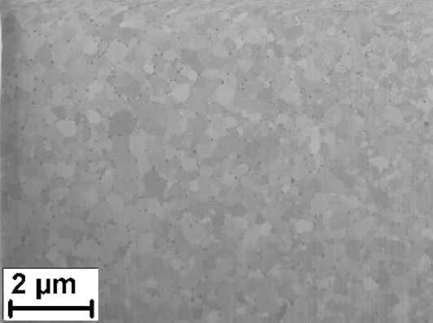
Fig.1. FIB analysis of the W-Cr-Y alloy cross section

All experiments were carried out in the ultrahigh vacuum MEDION facility [28–30], which allows irradiation of samples with a mass-separated deuterium ions, annealing and thermal desorption spectroscopy without air contact.
The samples were cleaned in an ultrasonic bath in ethanol before installation. After loading they were additionally heated in the ultra-high vacuum at the temperature of 1200 K for 15 minutes to relieve residual stresses induced in the process of sample preparation and unnecessary background signals during TDS measurements. Higher temperatures were not used to avoid transformation of the material and Cr evaporation.
At first, three series of room temperature (RT) irradiations with the fluence of D ions in the range of 10¹⁹– 5×10²¹ D/m² were performed for recrystallized and non-recrystallized pure W, and for W-Cr-Y alloy. Then, irradiations with the same fluence (10²¹ D/m²) and different sample temperatures (300–900 K) were performed for W-Cr-Y alloy and non-recrystallized W. The maximal temperature of 900 K corresponds to the expected operating conditions on the first wall of the DEMO reactor under steady state plasma conditions [31]. After each irradiation the TDS run was performed up to 1200 K. This temperature is sufficient for the complete release of deuterium from a pure W sample and almost complete release from W-Cr-Y alloy. The temperature was measured by a W-5%Re/W–20%Re thermocouple spot-welded directly to the sample.
In all experiments, TDS was performed 45 minutes after the end of irradiation with the heating rate of 2 K/s, except for experiments where the de-trapping energy was determined. To determine the energy of deuterium de-trapping in the W-Cr-Y alloy, experiments were carried out with varying of heating rate during TDS after irradiation of the sample with the same fluence (1×10²¹ D/m²) of D ions. In this case, the heating rate during TDS was set in the range of 0.2–2 K/s.
The D amount released from the sample during TDS was registered using the quadrupole mass spectrometer (QMS) Pfeiffer Vacuum QME 100. Deuterium containing signals (HD, HDO, D₂O) and some additional (including H₂, H₂O) were monitored. The calibration procedure was repeated after each TDS (see details in [30]).

3. Results and discussion
TDS data for pure W (non-recrystallized, recrystallized) and W-Cr-Y alloy samples irradiated with 2 keV D₃⁺ ions to the fluence of 1×10²¹ D/m² are shown in Fig.2(a). For pure W, all accumulated deuterium is released below 700 K. The major peak has a maximum at 410 K and several more peaks can be expected at higher temperatures, but they are not so pronounced. The amplitude of all peaks is higher for non-recrystallized W. It is expected due to a larger number of intrinsic defects. For example, the decrease of the dislocation density by about two orders of magnitude after recrystallization at 2000 K in comparison to annealing at 1200 K was observed in [26].

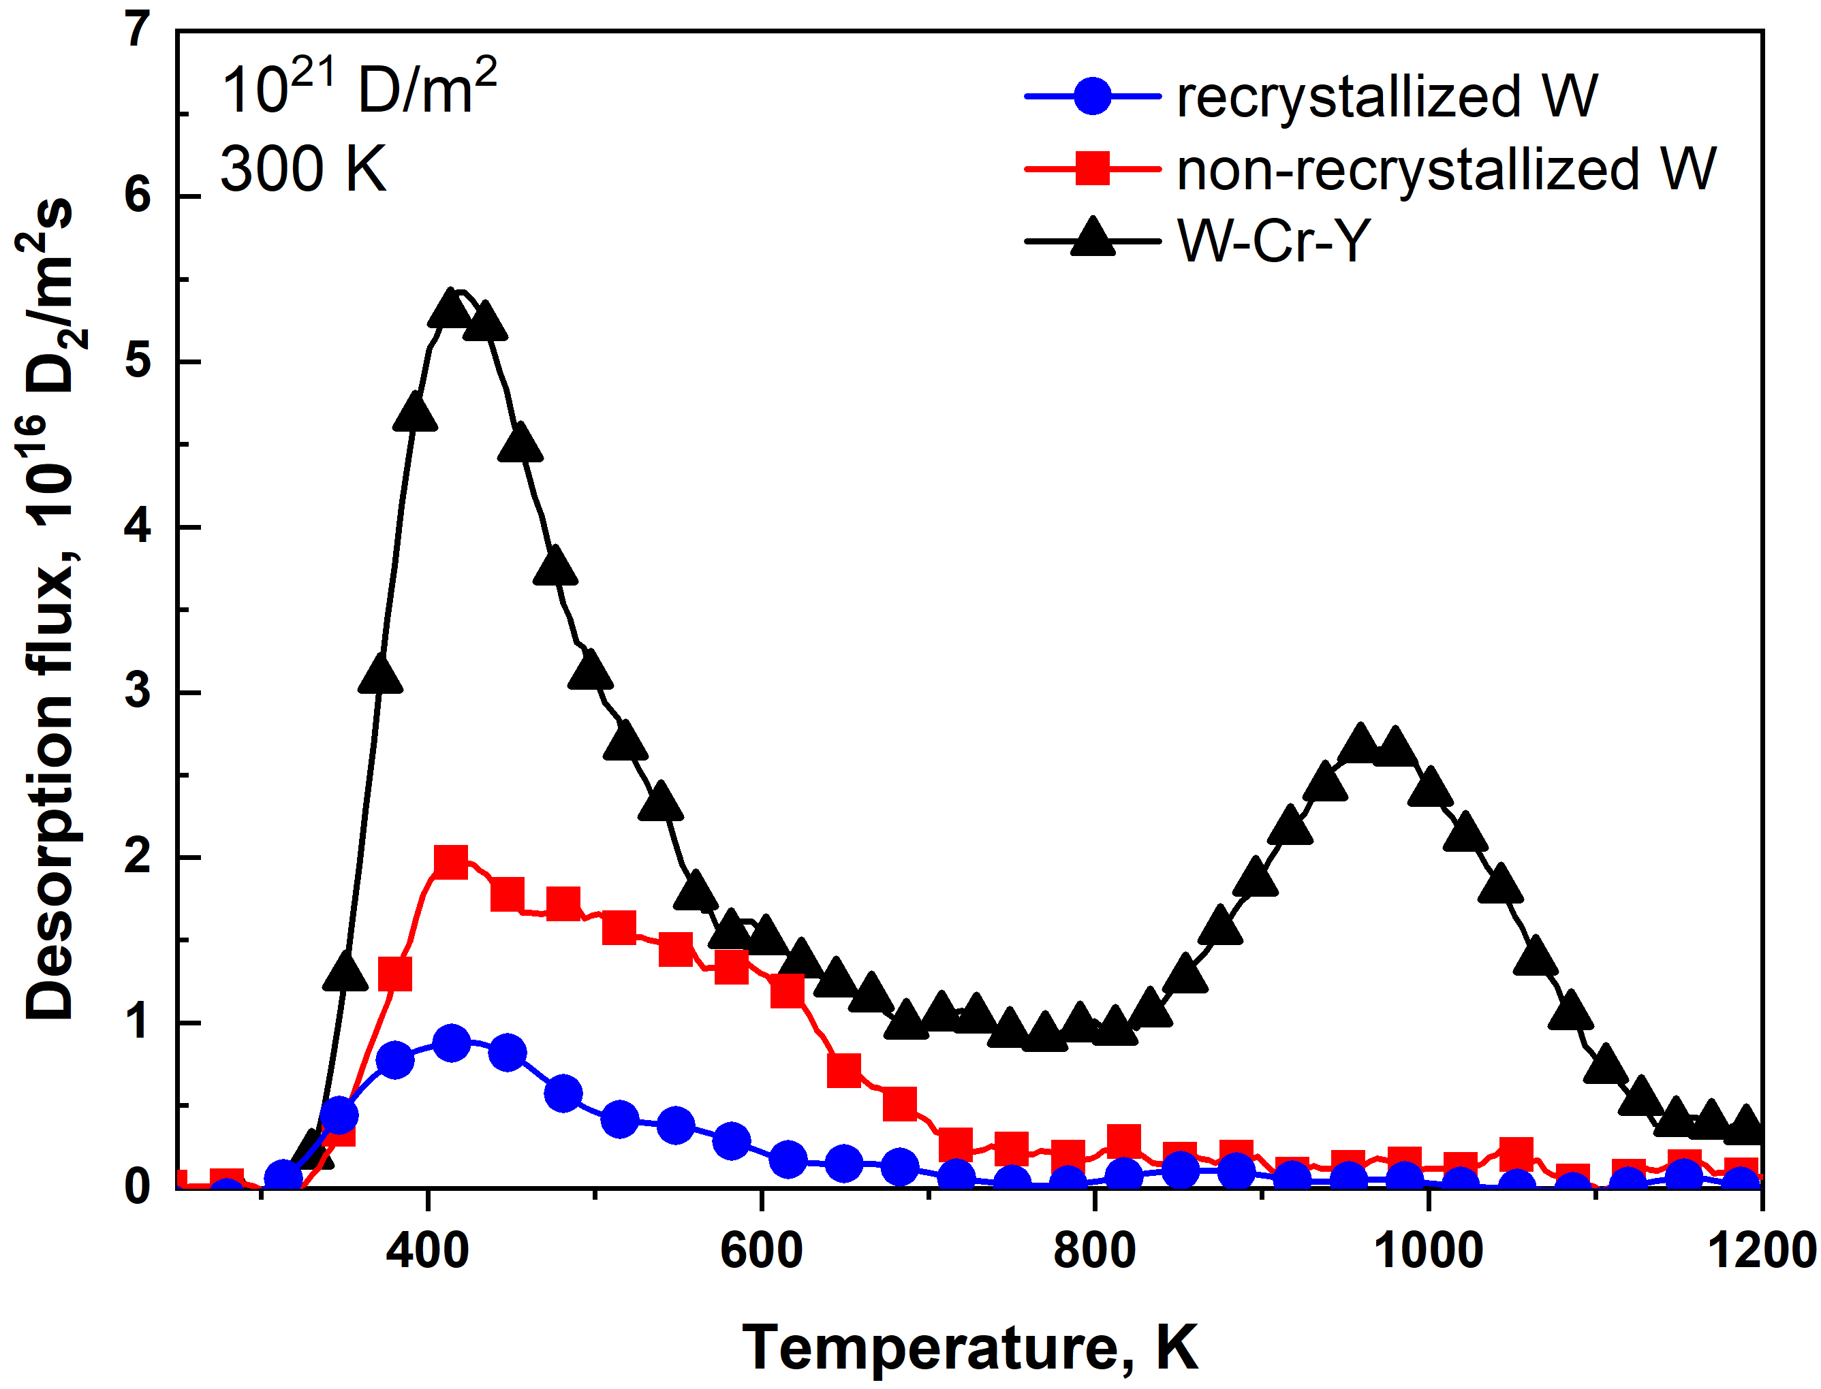
(a)
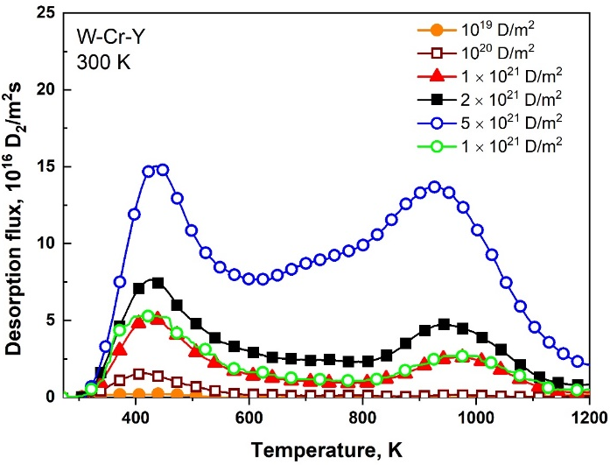
(b)
Fig.2. (a) TDS spectra of D₂ release from pure W and W–Cr–Y alloy samples irradiated with D₃⁺ ions with an energy of 2 keV to a fluence of 1×10²¹ D/m² at RT. (b) TDS spectra of D₂ release from W-Cr-Y alloy under irradiation with deuterium ions in the fluence range of 10¹⁹–5×10²¹ D/m² (the same sample was used in the series).

This release in the main peak (410 K) can be attributed to defects with low de-trapping energies of deuterium (up to 0.9 eV [32]), such as adsorption sites on the surface [33,34], grain boundaries, dislocations. Trapping sites with higher de-trapping energy usually attributed to vacancies [35–38] and can be both intrinsic and/or ion-induced even in the case of low energy irradiation below the threshold for displacement damage [39].
The release of deuterium from the W-Cr-Y alloy is higher. In addition to previous peaks, there is a high temperature part with a maximum at 965 K. The low temperature part (below 700 K) is also higher than in pure W, which is associated with a higher density of intrinsic defects.
Fig.2(b) demonstrates evolution of TDS spectra for W-Cr-Y alloy with the increase of the fluence. The high temperature peak is detectable only for relatively high fluences above 1×10²¹ D/m². At highest fluences, the amplitude of low and high temperature peaks is nearly equal. This indicates that these trapping sites are not concentrated in the implantation region, but distributed deeply into the bulk, and it takes time (or fluence) to fill a significant number of traps detectable by TDS. If the high-energy trapping sites were concentrated close to the implantation area, then a high-temperature peak would be observed already at lower irradiation fluences (10¹⁹, 10²⁰ D/m²) like it was in [35] in the case of high energy defects induced by ion irradiation. This is not observed that means accumulation in these traps needs some time for deuterium diffusion into deeper layers of the material.
One should mention that one sample was usually used for a long series of experiments. The total fluence of previous irradiations was usually lower than for the next irradiation. However, minor influence was observed even in the opposite case. In the Fig.2(b), there is an example of perfect reproducibility for experiments with W-Cr-Y alloy and the fluence of 1×10²¹ D/m² in the middle and in the end of the series.
To characterize trapping sites corresponding to high temperature release, a series of identical experiments has been performed with different heating rates during TDS. As it was discussed in [35,36], the Kissinger method [40,41] can be applied in this case to determine the de-trapping energy in the case of a high recombination rate at the surface. The peak position can be described using following equation:
, (1)
where is the heating rate (K/s), T_{max} is the maximum reaction rate temperature (K), E_{dt} is the de-trapping energy (eV), A is the pre-exponential factor (1/s), R is the gas constant (eV/K). The de-trapping energy can be derived from here as:
, (2)
Thus, the de-trapping energy can be estimated as the slope of the Arrhenius-like plot of versus .
In this series, the sample of W-Cr-Y alloy was irradiated several times at RT to the fluence of 1×10²¹ D/m². The heating rate was varied in the range of 0.2 – 2.0 K/s, as shown in Fig.3(а).
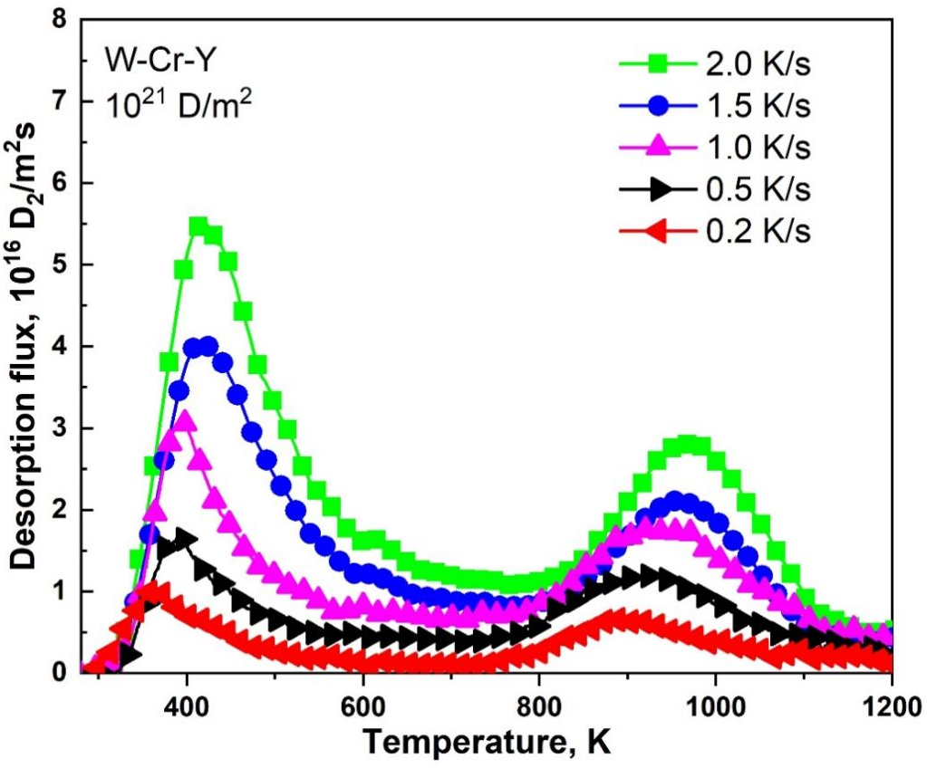
(a)
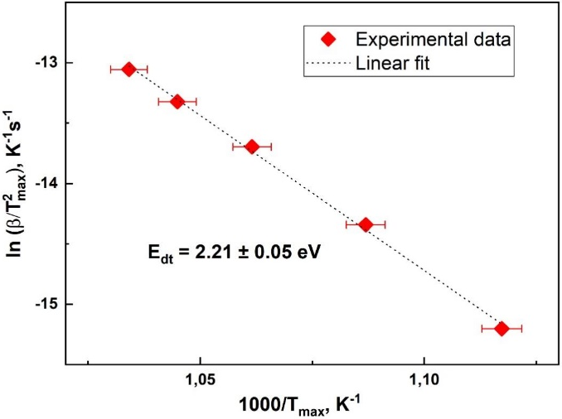
(b)
Fig.3. (a) TDS spectra of D₂ release from W-Cr-Y alloy after RT irradiation with the fluence of 1×10²¹ D/m² with different heating rates (0.2–2.0 K/s) indicated in the figure. (b) Arrhenius-like plot for estimating the de-trapping energy E_{dt} by the Kissinger method.

It is clearly seen that the second peak at 965 K shifts towards low temperatures to 895 K with a decrease in the heating rate from 2.0 K/s to 0.2 K/s. There was also a shift of the first peak from 410 K to 365 K. Note that at a heating rate of 2 K/s, the heating continues about 7 minutes, and already at a heating rate of 0.2 K/s, the heating duration exceeds 1 hour.
Fig.3(b) shows the Arrhenius-like plot of versus , where the maxima of the high-temperature peak are plotted and the best linear fit is presented according to the least squares analysis. According to calculation from the slope of the fit, the corresponding de-trapping energy is equal to 2.21±0.05 eV. In pure W, so high energy was attributed usually to some voids [30,38,42,43]. An enhanced porosity can be expected in W-Cr-Y alloys due to the way of manufacture. The average density of the material is about 99 %, as estimated in [44]. On the other hand, one cannot exclude the role of alloying elements in formation of these trapping sites.
Fig.4(a) demonstrates the fluence dependence of the total D retention for various materials. In all cases, the D accumulation was higher in W-Cr-Y alloy than in pure W, that correlates with results in [45]. The D retention in W-Cr-Y alloy reaches the level of 2-3 % of the total fluence for RT irradiation. The saturation of the D retention is not observed for our range of fluences that is in agreement with other data for pure W at these relatively small fluences [46,47]. Of particular interest is the retention of deuterium at operating temperatures expected in the DEMO reactor, which is approaching 900–1050 K [31]. A series of experiments have been performed at 900 K. Deuterium release from pure W was below the detection limit in this case. The D retention in W-Cr-Y alloy was detectable, but also significantly smaller than at RT. TDS spectra for this series are collected in Fig.4(b). Deuterium desorption starts after 900 K and some minor part was not desorbed even at the end of the TDS run. At temperatures above 800 K, a strong segregation of Cr and Y to the surface begins [48], as a result, the surface is saturated with the Cr-rich and Y-rich regions, which can create an additional surface barrier at high temperatures for D release.

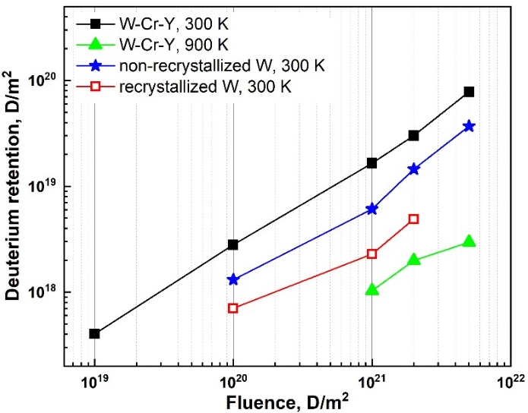
(a)

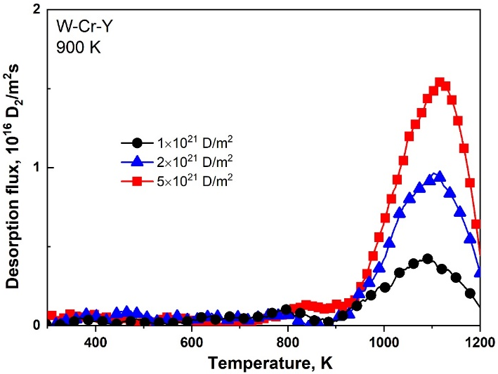
(b)
Fig.4. (a)The total D retention as a function of the irradiation fluence at RT and 900 K for recrystallized W, non-recrystallized (annealed at 1200 K) W, W-Cr-Y alloy. The data for high temperature exposure of pure W are below the detection limit. (b)TDS spectra of D₂ release from W-Cr-Y alloy irradiated at fluences in the range of 1×10²¹–5×10²¹ D/m² (the same sample was used in the series).

An additional series of experiments was done for the fixed fluence 10²¹ D/m² and different irradiation temperatures in the range of 300–900 K (Fig.5a). The highest retention is observed at irradiation temperature of 300 K. In the case of 400 K irradiation, the deuterium release starts already at ~ 420 K. The part below this temperature disappears, but the rest of the spectrum is very similar to RT irradiation. This may indicate that at 400 K irradiation, weak traps cannot hold deuterium for a long time any more, and diffusion of D and alloying elements is not high enough to influence accumulation in high energy traps.
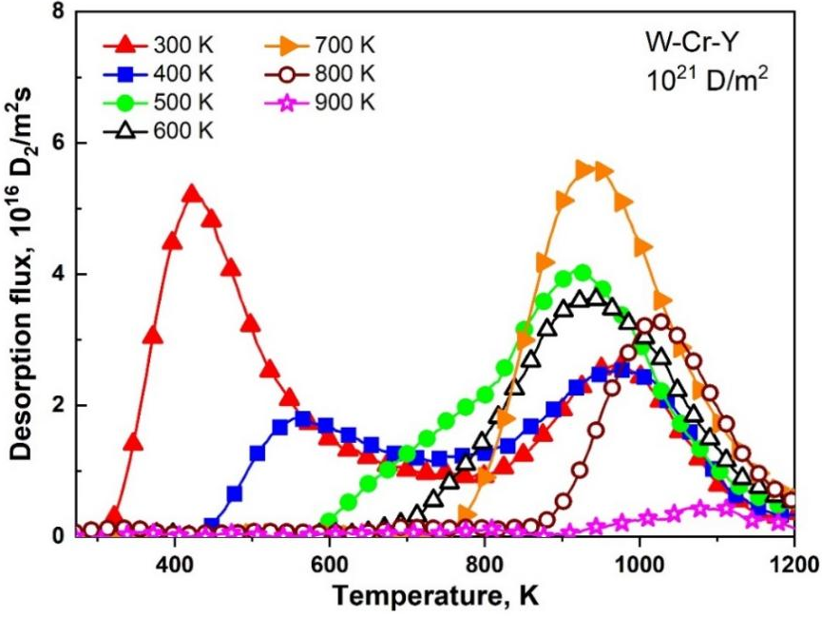
(a)
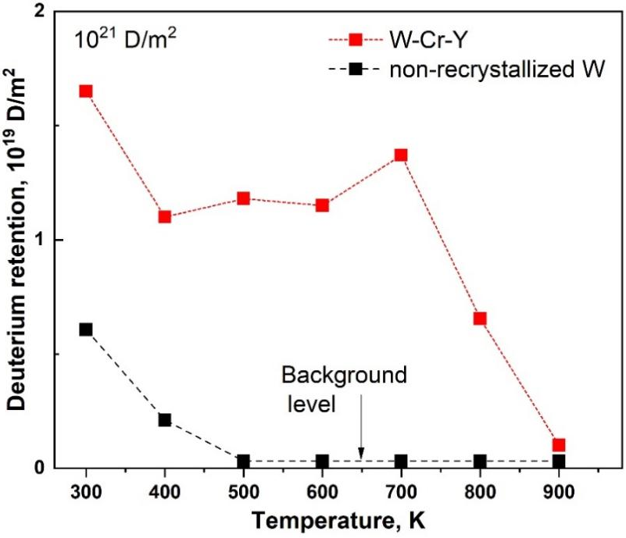
(b)
Fig.5. (a) TDS spectra of D₂ release from W-Cr-Y alloy irradiated at different temperatures in the range of 300–900 K. (b) Total retention of D from the sample irradiated with fluence of 10²¹ D/m² at different sample temperatures.

With a further increase of the irradiation temperature in the range of 500–700 K, an increase of high temperature peaks is observed. In contrast to pure W, the total D retention does not decrease and even slightly increase with a maximum at 700 K (Fig.5b). This should be due to the activation of diffusion processes. Firstly, mobility of D atoms allows them to go deeper in the bulk, where high energy traps are expected. On the other hand, the mobility of alloying elements (mainly Cr) is also activated in this temperature range [48]. A slight increase in the concentration of Cr and Y is observed on the surface at 500–700 K irradiation, which can be associated with the segregation of these elements on the surface. This can reduce the D desorption rate on the inlet surface and, respectively, increase the D concentration in the subsurface layer during irradiation and penetrating flux of D into the bulk. Additionally, the mobility of Cr and Y to the surface can lead to acceleration of D transport along grain boundaries.
Starting from 700 K, a sharp decrease in accumulation is observed. This should be associated with a decrease of the trapping efficiency and D population in traps, because this temperature is already close to the maximum of the main peak in TDS spectra. The segregation of alloying elements at the surface becomes even higher at these temperatures, but this process cannot compete with a weakness of traps.

4. Conclusions
The D retention in the W-Cr-Y alloy irradiated by 3keV D₃⁺ ions in the temperature range of 300–900 K was investigated and compared with pure polycrystalline W. In all cases, the D accumulation was higher in W-Cr-Y alloy. An additional high temperature peak with the maximum about 960 K was detected. Trapping sites associated with this peak play a major role in the increased D accumulation, especially, at high irradiation temperatures. The determined value of D de-trapping energy was 2.21±0.05 eV. Voids in the material could be the source of these strong traps. However, the role of alloying elements cannot be excluded.
The dependence of the D retention on the irradiation temperature has a local maximum of about 700 K. This can be explained by segregation of alloying elements at the surface and reduction of the D desorption rate. At 900 K, expected at the first wall in DEMO reactors, the D retention in the W-Cr-Y alloy drops down substantially. During TDS after high temperature irradiation, some part of deuterium released from the W-Cr-Y alloy above 1200 K.

Acknowledgments

The work was supported by the Russian Science Foundation project № 17-72-20191.

References
[1] T. Tanabe, Tritium fuel cycle in ITER and DEMO: Issues in handling large amount of fuel, J. Nucl. Mater. 438 (2013) S19–S26. https://doi.org/10.1016/j.jnucmat.2013.01.284.
[2] G. Mazzini, T. Kaliatka, M.T. Porfiri, Tritium and dust source term inventory evaluation issues in the European DEMO reactor concepts, Fusion Eng. Des. 146 (2019) 510–513.
https://doi.org/10.1016/j.fusengdes.2019.01.008.
[3] J. Roth, E. Tsitrone, T. Loarer, V. Philipps, S. Brezinsek, A. Loarte, G.F. Counsell, R.P. Doerner, K. Schmid, O. V. Ogorodnikova, R.A. Causey, Tritium inventory in ITER plasma-facing materials and tritium removal procedures, Plasma Phys. Control. Fusion. 50 (2008). https://doi.org/10.1088/0741-3335/50/10/103001.
[4] V. Philipps, Tungsten as material for plasma-facing components in fusion devices, J. Nucl. Mater. 415 (2011) S2. https://doi.org/10.1016/j.jnucmat.2011.01.110.
[5] R.A. Pitts, X. Bonnin, F. Escourbiac, H. Frerichs, J.P. Gunn, T. Hirai, A.S. Kukushkin, E. Kaveeva, M.A. Miller, D. Moulton, V. Rozhansky, I. Senichenkov, E. Sytova, O. Schmitz, P.C. Stangeby, G. De Temmerman, I. Veselova, S. Wiesen, Physics basis for the first ITER tungsten divertor, Nucl. Mater. Energy. 20 (2019) 100696. https://doi.org/10.1016/j.nme.2019.100696.
[6] C. Bachmann, F. Arbeiter, L.V. Boccaccini, M. Coleman, G. Federici, U. Fischer, R. Kemp, F. Maviglia, G. Mazzone, P. Pereslavtsev, R. Roccella, N. Taylor, R. Villari, F. Villone, R. Wenninger, J.-H. You, Issues and strategies for DEMO in-vessel component integration, Fusion Eng. Des. 112 (2016) 527–534.
https://doi.org/10.1016/j.fusengdes.2016.05.040.
[7] T. Tanabe, Review of hydrogen retention in tungsten, Phys. Scr. T159 (2014) 014044.
https://doi.org/10.1088/0031-8949/2014/T159/014044.
[8] F. Koch, J. Brinkmann, S. Lindig, T.P. Mishra, C. Linsmeier, Oxidation behaviour of silicon-free tungsten alloys for use as the first wall material, Phys. Scr. T. T145 (2011).
https://doi.org/10.1088/0031-8949/2011/T145/014019.
[9] A. Litnovsky, T. Wegener, F. Klein, C. Linsmeier, M. Rasinski, A. Kreter, B. Unterberg, M. Vogel, S. Kraus, U. Breuer, C. Garcia-Rosales, A. Calvo, N. Ordas, Smart alloys for a future fusion power plant: First studies under stationary plasma load and in accidental conditions, Nucl. Mater. Energy. 12 (2017) 1363–1367.
https://doi.org/10.1016/j.nme.2016.11.015.
[10] C. Linsmeier, M. Rieth, J. Aktaa, T. Chikada, A. Hoffmann, J. Hoffmann, A. Houben, H. Kurishita, X. Jin, M. Li, A. Litnovsky, S. Matsuo, A. Von Müller, V. Nikolic, T. Palacios, R. Pippan, D. Qu, J. Reiser, J. Riesch, T. Shikama, R. Stieglitz, T. Weber, S. Wurster, J.H. You, Z. Zhou, Development of advanced high heat flux and plasma-facing materials, Nucl. Fusion. 57 (2017).
https://doi.org/10.1088/1741-4326/aa6f71.
[11] N. Taylor, S. Ciattaglia, H. Boyer, D. Coombs, X.Z. Jin, K. Liger, J.C. Mora, G. Mazzini, T. Pinna, E. Urbonavičius, Resolving safety issues for a demonstration fusion power plant, Fusion Eng. Des. 124 (2017) 1177–1180. https://doi.org/10.1016/j.fusengdes.2017.02.018.
[12] M. Nakamura, K. Tobita, W. Gulden, K. Watanabe, Y. Someya, H. Tanigawa, Y. Sakamoto, T. Araki, H. Matsumiya, K. Ishii, H. Utoh, H. Takase, T. Hayashi, A. Satou, T. Yonomoto, G. Federici, K. Okano, Study of safety features and accident scenarios in a fusion DEMO reactor, Fusion Eng. Des. 89 (2014) 2028–2032. https://doi.org/10.1016/j.fusengdes.2014.04.062.
[13] N. Taylor, P. Cortes, Lessons learnt from ITER safety & licensing for DEMO and future nuclear fusion facilities, Fusion Eng. Des. 89 (2014) 1995–2000. https://doi.org/10.1016/j.fusengdes.2013.12.030.
[14] M. Nakamura, K. Tobita, Y. Someya, H. Utoh, Y. Sakamoto, W. Gulden, Safety research on fusion DEMO in Japan: Toward development of safety strategy of a water-cooled DEMO, Fusion Eng. Des. 109–111 (2016) 1417–1421.
https://doi.org/10.1016/j.fusengdes.2015.12.008.

[15] D. Maisonnier, I. Cook, S. Pierre, B. Lorenzo, B. Edgar, B. Karin, D.P. Luigi, F. Robin, G. Luciano, H. Stephan, N. Claudio, N. Prachai, P. Aldo, T. Neill, W. David, The European power plant conceptual study, Fusion Eng. Des. 75–79 (2005) 1173–1179. https://doi.org/10.1016/j.fusengdes.2005.06.095.
[16] D. Tsuru, Y. Neyatani, T. Araki, K. Nomoto, S. O’Hira, T. Maruo, M. Hashimoto, K. Hada, E. Tada, Study on decay heat removal of compact ITER, Fusion Eng. Des. 58–59 (2001) 985–989. https://doi.org/10.1016/S0920-3796(01)00229-0.
[17] M. Gillet, R. Delamare, E. Gillet, Growth of epitaxial tungsten oxide nanorods, J. Cryst. Growth. 279 (2005) 93–99. https://doi.org/10.1016/j.jcrysgro.2005.01.089.
[18] G.R. Smolik, R.J. Pawelko, R.A. Anderl, D.A. Petti, Oxidation and volatilization from tungsten brush high heat flux armor during steam exposure, Fusion Eng. Des. 54 (2001) 583–591. https://doi.org/10.1016/S0920-3796(00)00571-8.
[19] T. Wegener, F. Klein, A. Litnovsky, M. Rasinski, J. Brinkmann, F. Koch, C. Linsmeier, Development and analyses of self-passivating tungsten alloys for DEMO accidental conditions, Fusion Eng. Des. 124 (2017) 183–186. https://doi.org/10.1016/j.fusengdes.2017.03.072.
[20] F. Koch, H. Bolt, Self passivating W-based alloys as plasma facing material for nuclear fusion, Phys. Scr. T. T128 (2007) 100–105. https://doi.org/10.1088/0031-8949/2007/T128/020.
[21] F. Koch, S. Köppl, H. Bolt, Self passivating W-based alloys as plasma-facing material, J. Nucl. Mater. 386–388 (2009) 572–574. https://doi.org/10.1016/j.jnucmat.2008.12.179.
[22] A. Litnovsky, T. Wegener, F. Klein, C. Linsmeier, M. Rasinski, A. Kreter, X. Tan, J. Schmitz, J.W. Coenen, Y. Mao, J. Gonzalez-Julian, M. Bram, New oxidation-resistant tungsten alloys for use in the nuclear fusion reactors, Phys. Scr. 2017 (2017).
https://doi.org/10.1088/1402-4896/aa81f5.
[23] T. Wegener, F. Klein, A. Litnovsky, M. Rasinski, J. Brinkmann, F. Koch, C. Linsmeier, Development of yttrium-containing self-passivating tungsten alloys for future fusion power plants, Nucl. Mater. Energy. 9 (2016) 394–398.
https://doi.org/10.1016/j.nme.2016.07.011.
[24] A. Litnovsky, T. Wegener, F. Klein, C. Linsmeier, M. Rasinski, A. Kreter, B. Unterberg, J.W. Coenen, H. Du, J. Mayer, C. Garcia-Rosales, A. Calvo, N. Ordas, Smart tungsten alloys as a material for the first wall of a future fusion power plant, Nucl. Fusion. 57 (2017).
https://doi.org/10.1088/1741-4326/aa6816.
[25] J. Roth, K. Schmid, Hydrogen in tungsten as plasma-facing material, Phys. Scr. T. T145 (2011).
https://doi.org/10.1088/0031-8949/2011/T145/014031.
[26] A. Manhard, M. Balden, S. Elgeti, Quantitative Microstructure and Defect Density Analysis of Polycrystalline Tungsten Reference Samples after Different Heat Treatments, Pract. Metallogr. 52 (2015) 437–466. https://doi.org/10.3139/147.110354.
[27] O. Guillon, J. Gonzalez-Julian, B. Dargatz, T. Kessel, G. Schierning, J. Räthel, M. Herrmann, Field-assisted sintering technology/spark plasma sintering: Mechanisms, materials, and technology developments, Adv. Eng. Mater. 16 (2014) 830–849.
https://doi.org/10.1002/adem.201300409.
[28] S.A. Ryabtsev, Y.M. Gasparyan, V.S. Efimov, Z.R. Harutyunyan, A.G. Poskakalov, A.A. Pisarev, S.L. Kanashenko, Y.D. Ivanov, Influence of the Initial Defect Structure on Helium Trapping in Tungsten under Ion Implantation, Phys. At. Nucl. 81 (2018) 1541–1546. https://doi.org/10.1134/S1063778818110170.
[29] Z.R. Harutyunyan, Y.M. Gasparyan, V.S. Efimov, S.A. Ryabtsev, A.A. Pisarev, Retention of Deuterium in the Surface Layers of Tungsten Preliminarily Irradiated with Helium Ions, Bull. Russ. Acad. Sci. Phys. 84 (2020) 727–731.
https://doi.org/10.3103/S1062873820060040.
[30] Z. Harutyunyan, Y. Gasparyan, S. Ryabtsev, V. Efimov, O. Ogorodnikova, A. Pisarev, S. Kanashenko, Deuterium trapping in the subsurface layer of tungsten pre-irradiated with helium ions, J. Nucl. Mater. 548 (2021) 152848. https://doi.org/10.1016/j.jnucmat.2021.152848.
[31] Y. Igitkhanov, B. Bazylev, I. Landman, Plasma facing materials lifetime in steady-state demo operation, Fusion Sci. Technol. 64 (2013) 245–249. https://doi.org/10.13182/FST13-A18084.
[32] A. Pisarev, B. Giniyatullin, Influence of True Diffusion Coefficient on Hydrogen Diffusion in Tungsten in the Field of Defects, J. Phys. Conf. Ser. 1370 (2019).
https://doi.org/10.1088/1742-6596/1370/1/012061.
[33] H. Eleveld, A. van Veen, Deuterium interaction with impurities in tungsten studied with TDS, J. Nucl. Mater. 191–194 (1992) 433–438. https://doi.org/10.1016/S0022-3115(09)80082-2.
[34] D.F. Johnson, E.A. Carter, Hydrogen in tungsten: Absorption, diffusion, vacancy trapping, and decohesion, J. Mater. Res. 25 (2010) 315–327. https://doi.org/10.1557/jmr.2010.0036.
[35] S. Ryabtsev, Y. Gasparyan, M. Zibrov, A. Shubina, A. Pisarev, Deuterium thermal desorption from vacancy clusters in tungsten, Nucl. Instruments Methods Phys. Res. Sect. B Beam Interact. with Mater. Atoms. 382 (2016) 101–104.
https://doi.org/10.1016/j.nimb.2016.04.038.
[36] M. Zibrov, S. Ryabtsev, Y. Gasparyan, A. Pisarev, Experimental determination of the deuterium binding energy with vacancies in tungsten, J. Nucl. Mater. 477 (2016) 292–297. https://doi.org/10.1016/j.jnucmat.2016.04.052.
[37] O. V. Ogorodnikova, J. Roth, M. Mayer, Deuterium retention in tungsten in dependence of the surface conditions, J. Nucl. Mater. 313–316 (2003) 469–477.
https://doi.org/10.1016/S0022-3115(02)01375-2.
[38] O. V. Ogorodnikova, J. Roth, M. Mayer, Ion-driven deuterium retention in tungsten, J. Appl. Phys. 103 (2008).
https://doi.org/10.1063/1.2828139.
[39] M. Poon, R.G. MacAulay-Newcombe, J.W. Davis, A.A. Haasz, Effects of background gas impurities during D+ irradiation on D trapping in single crystal tungsten, J. Nucl. Mater. 337–339 (2005) 629–633. https://doi.org/10.1016/j.jnucmat.2004.09.042.
[40] Homer E. Kissinger, Variation of Peak Temperature With Heating Rate in Differential Thermal Analysis, J. Res. Natl. Bur. Stand. (1934). 57 (1956) 217–221.
https://doi.org/10.1002/9781119959809.ch9.
[41] H.E. Kissinger, Reaction Kinetics in Differential Thermal Analysis, Anal. Chem. 29 (1957) 1702–1706.
https://doi.org/10.1021/ac60131a045.
[42] A. Van Veen, H.A. Filius, J. De Vries, K.R. Bijkerk, G.J. Rozing, D. Segers, Hydrogen exchange with voids in tungsten observed with TDS and PA, J. Nucl. Mater. 155–157 (1988) 1113–1117.
https://doi.org/10.1016/0022-3115(88)90478-3.
[43] M. Poon, A.A. Haasz, J.W. Davis, Modelling deuterium release during thermal desorption of D+-irradiated tungsten, J. Nucl. Mater. 374 (2008) 390–402.
https://doi.org/10.1016/j.jnucmat.2007.09.028.
[44] A. Litnovsky, F. Klein, J. Schmitz, T. Wegener, C. Linsmeier, M.R. Gilbert, M. Rasinski, A. Kreter, X. Tan, Y. Mao, J.W. Coenen, M. Bram, J. Gonzalez-Julian, Smart first wall materials for intrinsic safety of a fusion power plant, Fusion Eng. Des. 136 (2018) 878–882. https://doi.org/10.1016/j.fusengdes.2018.04.028.
[45] H. Maier, T. Schwarz-Selinger, R. Neu, C. Garcia-Rosales, M. Balden, A. Calvo, T. Dürbeck, A. Manhard, N. Ordás, T.F. Silva, Deuterium retention in tungsten based materials for fusion applications, Nucl. Mater. Energy. 18 (2019) 245–249.
https://doi.org/10.1016/j.nme.2018.12.032.
[46] Z. Tian, J.W. Davis, A.A. Haasz, Deuterium retention in tungsten at fluences of up to 1026 D+/m2 using D+ ion beams, J. Nucl. Mater. 399 (2010) 101–107.
https://doi.org/10.1016/j.jnucmat.2010.01.007.
[47] V.K. Alimov, J. Roth, Hydrogen isotope retention in plasma-facing materials: Review of recent experimental results, Phys. Scr. T. T128 (2007) 6–13.
https://doi.org/10.1088/0031-8949/2007/T128/002.
[48] H.R. Koslowski, J. Schmitz, C. Linsmeier, Segregation and preferential sputtering of Cr in WCrY smart alloy, Nucl. Mater. Energy. 22 (2020) 100736.
https://doi.org/10.1016/j.nme.2020.100736.

